1) Alter the table STUDENT with following structure.

|  |  |  |
| --- | --- | --- |
|  | Column | Constraints |
| # | Name |  |
|  |  | PRIMARY |
| 1 | RegNo | KEY |
| 2 | MobileNo | NOT NULL |

1.  
[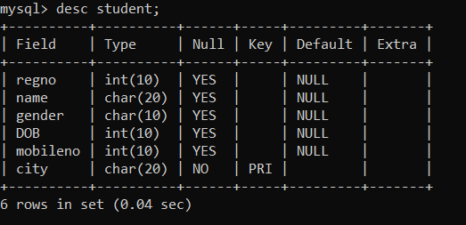](https://user-images.githubusercontent.com/113232880/193640010-0c00c6ae-66be-4545-94ee-6dc8fd273975.png)

1. Alter the table name FACULTY with following structure. The DeptNo in this table refers the DeptNo in the DEPARTMENT table.

|  |  |  |  |  |  |  |  |  |  |
| --- | --- | --- | --- | --- | --- | --- | --- | --- | --- |
|  |  |  | Column | | Constraints |  |  |  |  |
|  | # |  | Name | |  |  |  |  |  |
|  |  |  | FacNo | | PRIMARY |  |  |  |  |
|  | 1 |  | KEY |  |  |  |  |
|  |  |  |  |  |  |  |  |
|  |  |  | Gender | | CHECK |  |  |  |  |
|  | 2 |  | ‘M’ or ‘F’ |  |  |  |  |
|  |  |  |  |  |  |  |  |

[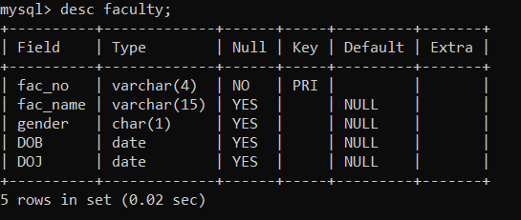](https://user-images.githubusercontent.com/113232880/193640098-c58fedad-4b2f-40c2-9375-0c3f1f5d514b.png)

|  |  |  |  |  |  |  |  |
| --- | --- | --- | --- | --- | --- | --- | --- |
| 3) | After the FACULTY table is successfully created, test if you can add a constraint | | | | | | |
| FOREIGN KEY to the DeptNo of this table. | | | | | | | |
| 4) | Alter the table name DEPARTMENT with following structure. | | | | | | |
|  |  |  |  |  | |  |  |
|  |  | Column |  | Constraint | |  |  |
| # |  | Name |  |  |  |  |  |
|  |  | DeptNo |  | PRIMARY | |  |  |
| 1 |  |  | KEY | |  |  |
|  |  |  |  |  |

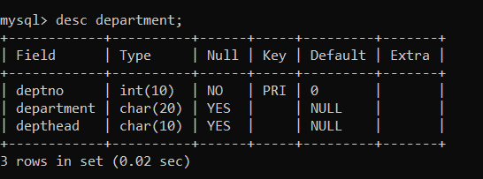

|  |  |  |  |  |  |  |  |  |  |
| --- | --- | --- | --- | --- | --- | --- | --- | --- | --- |
|  | 5) | Alter the table name COURSE with following structure. | | | | | | |  |
|  |  |  |  | |  | | |  |  |
|  |  |  | Column |  | Constraint | | |  |  |
|  | # |  | Name |  |  |  |  |  |  |
|  |  |  | CourseNo |  | PRIMARY | | |  |  |
|  | 1 |  |  | KEY | | |  |  |
|  |  |  |  |  |  |
|  | 2 |  | SemNo |  | 1 to 6 | | |  |  |

